S.R.R AND C.V.R GOVERNMENT DEGREE COLLEGE (A), VIJAYAWADA
DEPARTMENT OF ENGLISH: ONE DAY
INTERNATIONAL VIRTUAL CONFERENCE HELD ON
05-02-2022 ON THE TOPIC ‘RESEARCH METHODOLOGIES OF CONTEMPORARY TIMES: EXPLORING ENGLISH LANGUAGE, LITERATURE AND TEACHING’
TIME: 9AM to 1PM (IST)

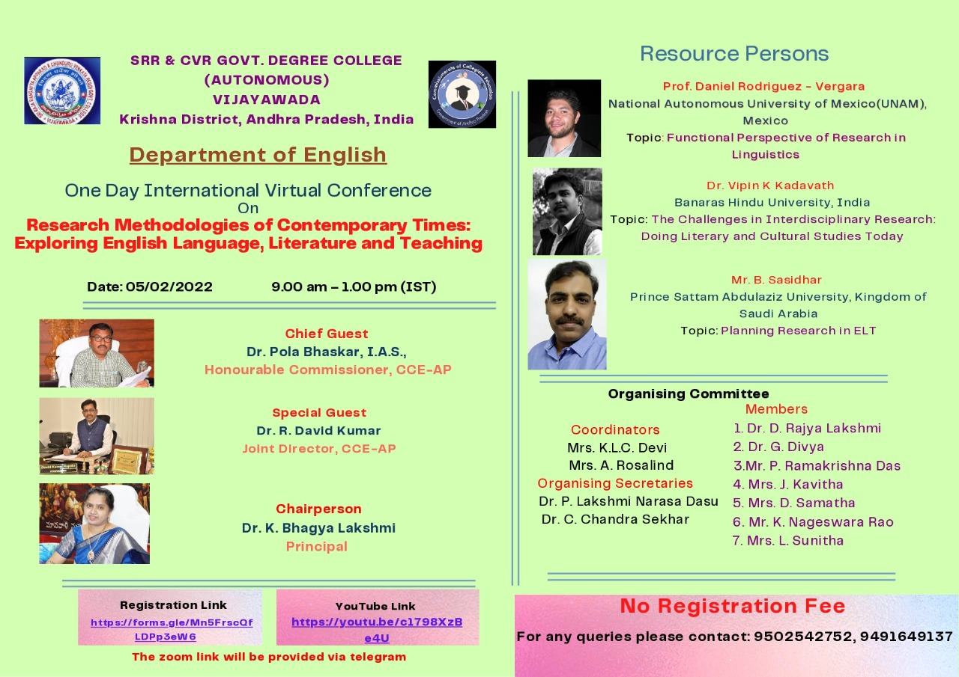

REPORT OF ONE DAY INTERNATIONAL VIRTUAL CONFERENCE: For this One Day International Virtual Conference 1476 registrations were received from 12 countries viz… Bangladesh, Bhutan, India, Iraq, Nepal, Oman, Pakistan, Philippines, Saudi Arabia, Sri Lanka, Thailand, and Ukraine The department of English recorded the registrations from almost all States in India except Ladakh and Sikkim.

RESOURCE PERSONS:
- Dr. Daniel Rodriguez-Vergara
(National Autonomous University of Mexico, *Mexico*)
Topic: “Functional Perspective of Research in Linguistics”.

2. Dr. Vipin K Kadavath
(Banaras Hindu University, *India*)
Topic: “The Challenges in Interdisciplinary Research: Doing Literary and Cultural Studies Today”.

3. Mr. B. Sasidhar
(Prince Sattam Bin Abdulaziz University, *Saudi Arabia*)
Topic: “Planning Research in ELT”

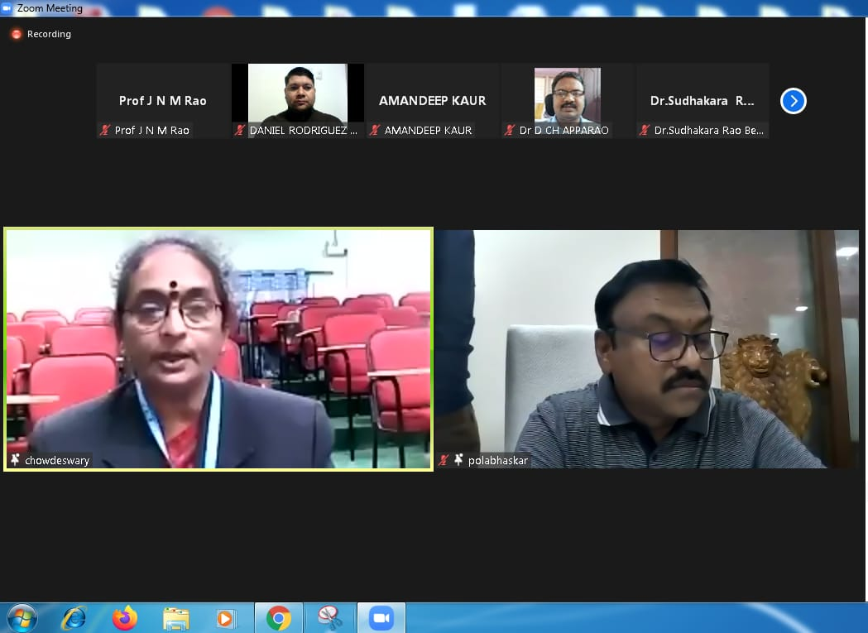

Honourable Commissioner of Collegiate Education Dr. Pola Bhaskar, I.A.S acted as the Chief Guest. Honourable Commissioner Sir encouraged the College and the department of English in organizing the International Conference. Also the Commissioner highlighted the importance of such conferences in colleges in inculcating and enhancing the quality of teaching among the staff members to further promoting good standards of learning among the students.
Mrs. K. L. C. Devi, Head of the Department of English welcomed the Chairperson of the Conference, Dr. K. Bhagya Lakshmi, the Principal of S.R.R AND C.V.R Government College, the Commissioner of Collegiate Education, Dr. Pola Bhaskar, I.A.S, the Chief Guest, the Joint Director, C.C.E, Dr. R. David Kumara Swamy, the Resource Persons and the participants from all countries and the States in India.

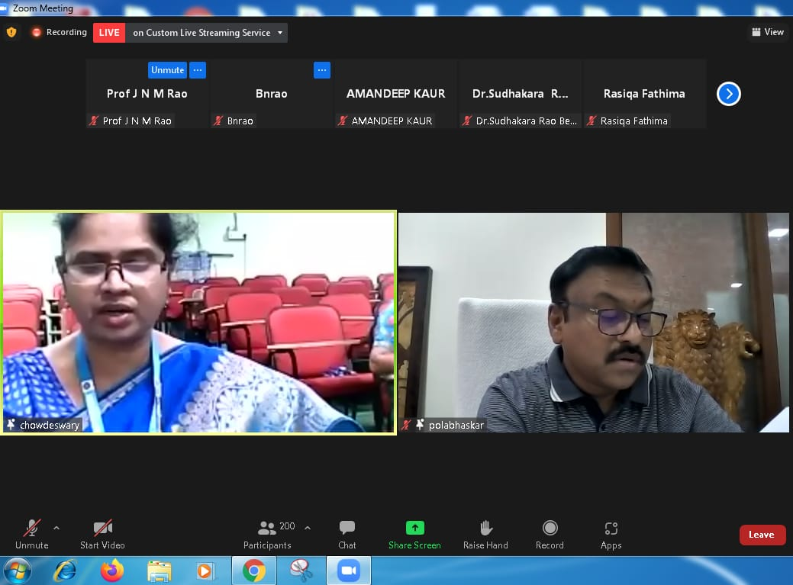

The Chairperson of the Conference, Dr. K. Bhagya Lakshmi madam, the Principal of S.R.R AND C.V.R Government College enlightened on the significance of English language in present scenario of Employment, as means of communication fetching the job opportunities for students.
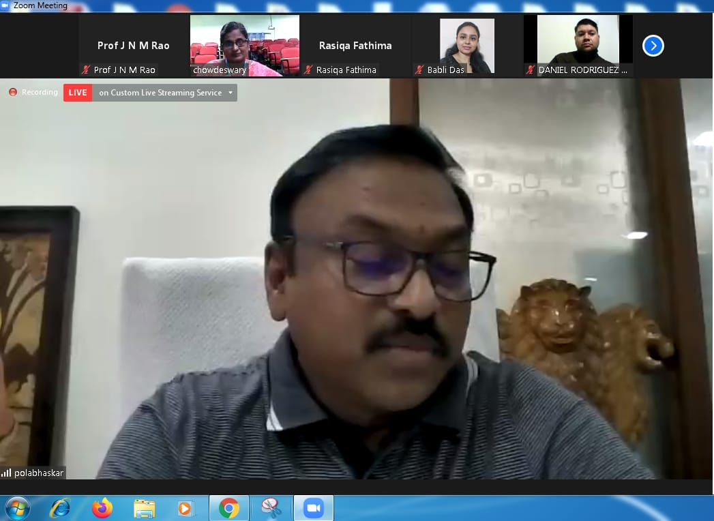

Honourable Commissioner Sir Dr. Pola Bhaskar, I.A.S brought home the importance of teaching English in colleges to encourage and train up the students for better future. The Chief Guest also reiterated to explore the employment opportunities for the student community and to get them ready with such soft skills and the skills of Communication.

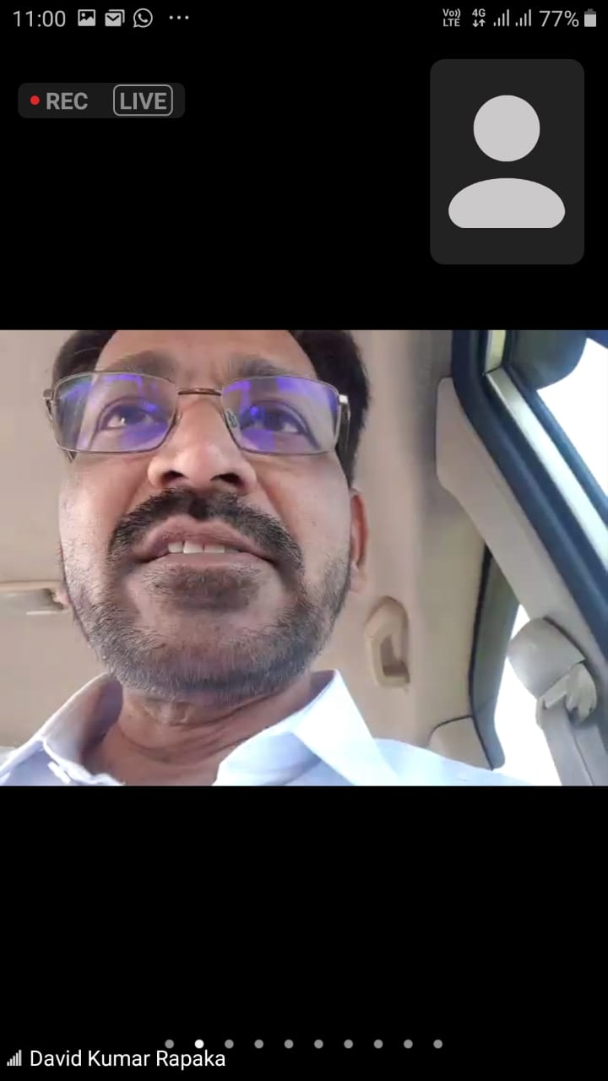
The Joint Director, C.C.E, Dr. R. David Kumara Swamy, the Special Guest congratulated the participants for evincing interest in such International Virtual Conferences since the common the global interests of Education and teaching could be met during the conference. The Joint Director also wished to have more and more conferences to happen in Government Colleges and all other institutions.
Details of Resource Persons:
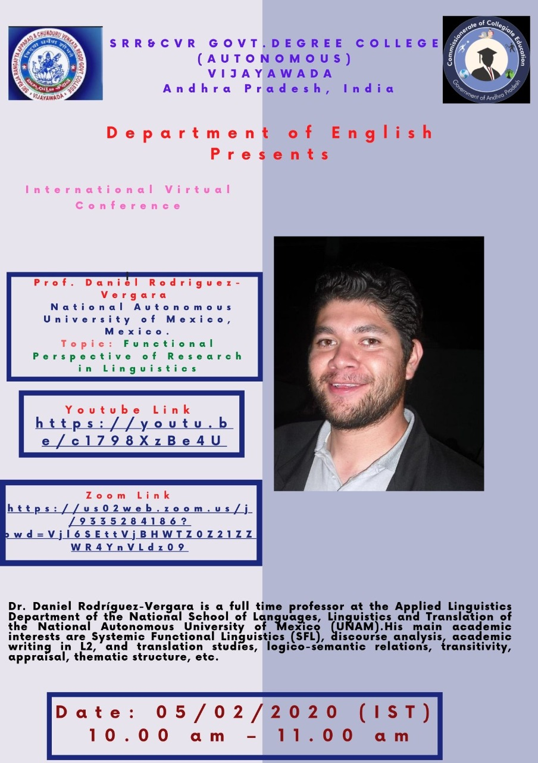
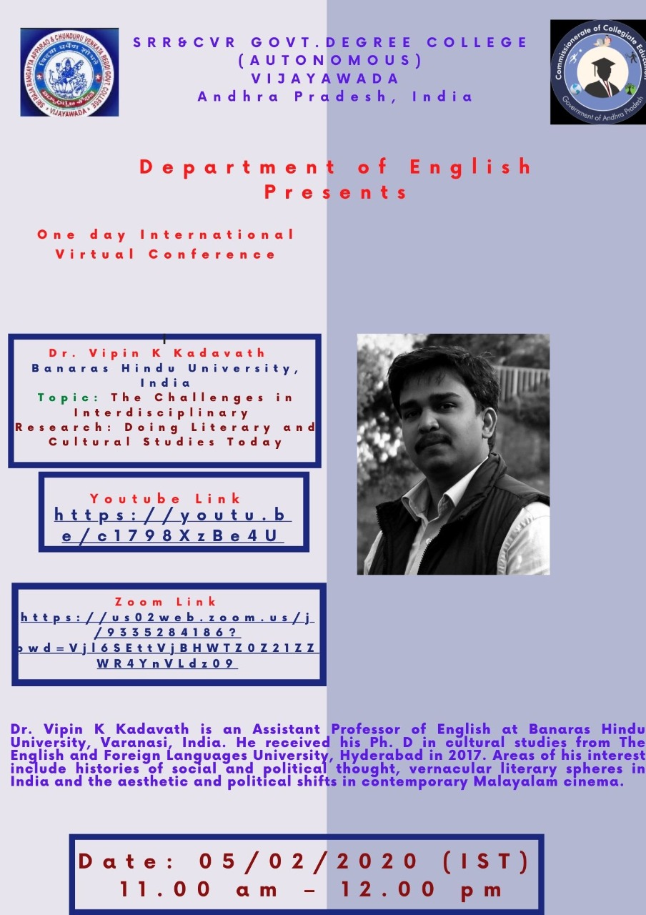
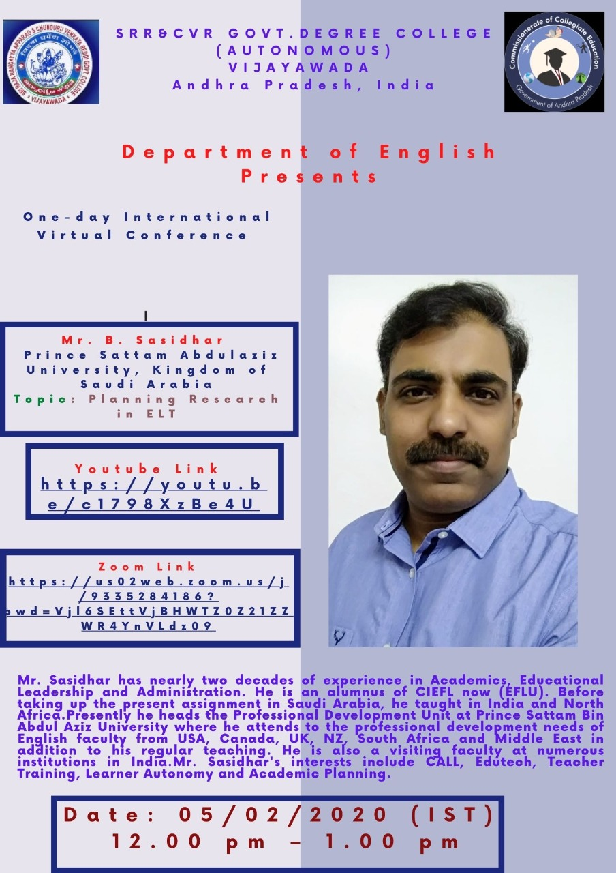

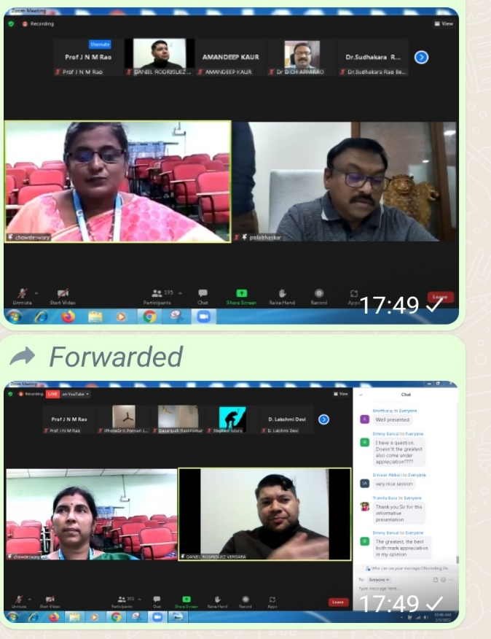 | 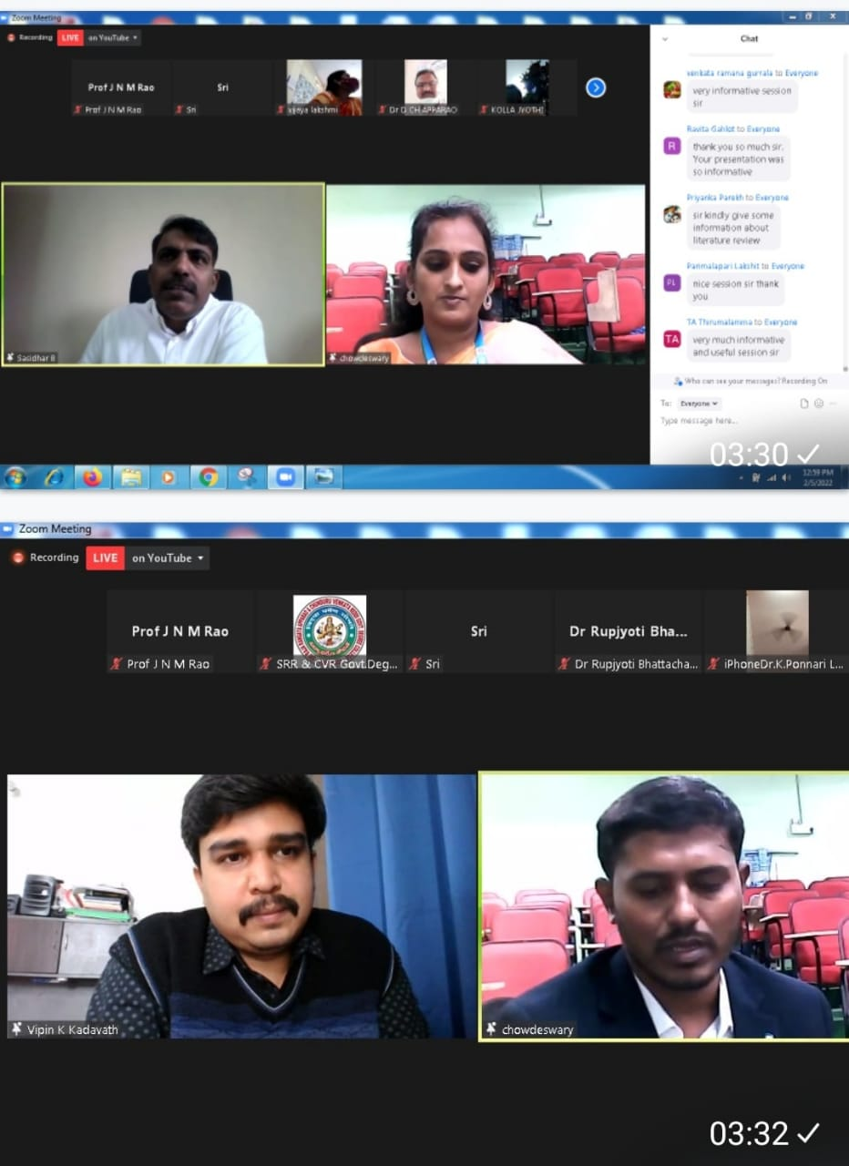
Mrs A. Rosalind, Lecturer in English introduced the Chief Guest Dr. Pola Bhaskar, the Commissioner of Collegiate Education.
Dr. D. Rajya Lakshmi, Lecturer in English led the Questions and Answers Session of the resource person Dr. Daniel Rodriguez – Vergara (National Autonomous University of Mexico, *Mexico*) on the topic: “Functional Perspective of Research in Linguistics”.
Dr. C. Chandra Sekhar, Lecturer in English introduced the resource person Dr. Vipin K Kadavath (Banaras Hindu University, *India*) who presented the topic: “The Challenges in Interdisciplinary Research: Doing Literary and Cultural Studies Today”.

Dr. G. Divya Lecturer in English led the Questions and Answers Session of the resource person Mr. B. Sasidhar (Prince Sattam Bin Abdulaziz University, *Saudi Arabia*) on the topic: “Planning Research in English Language Teaching”

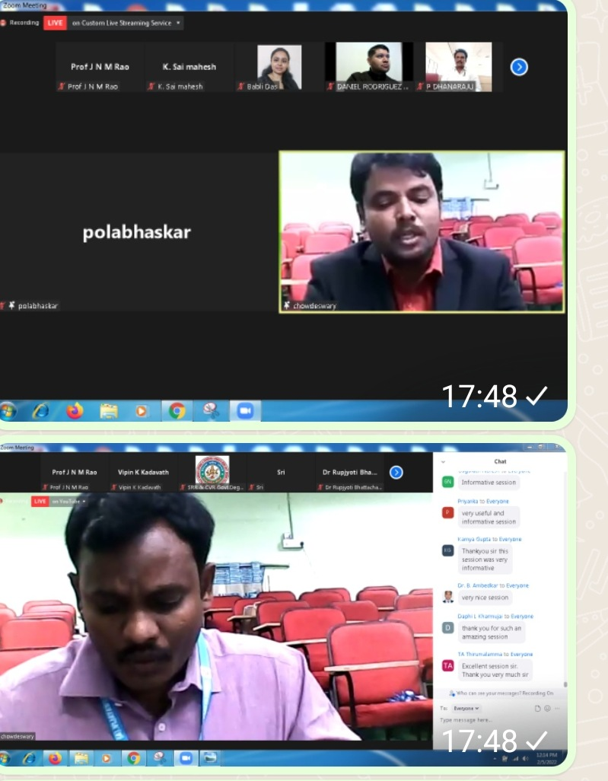 | 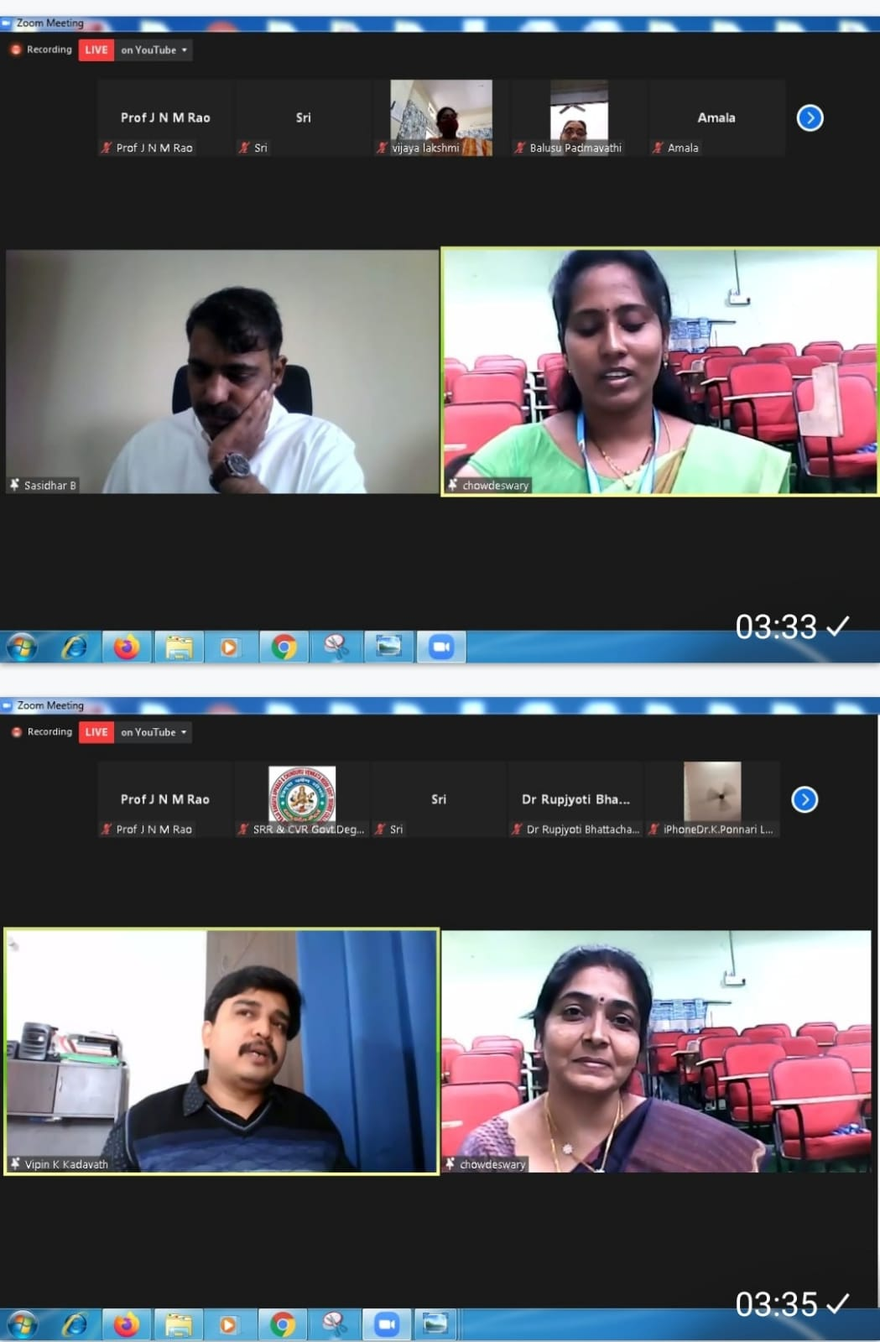

Dr. P. L. N. Dasu, Lecturer in English introduced the resource person.Dr. Daniel Rodriguez-Vergara, (National Autonomous University of Mexico, *Mexico*) who spoke on the topic: “Functional Perspective of Research in Linguistics”.
J. Kavitha, Lecturer in English led the Questions and Answers Session of the resource person Dr. Vipin K Kadavath (Banaras Hindu University, *India*) on the
topic: “The Challenges in Interdisciplinary Research: Doing Literary and Cultural Studies Today”.
Sri P. Rama Krishna Das, Lecturer in English introduced the resource person Mr. B. Sasidhar (Prince Sattam Bin Abdulaziz University, *Saudi Arabia*) on the topic: “Planning Research in ELT”
L. Sunitha, Lecturer in English led the Questions and Answers Session of the resource person Mr. B. Sasidhar (Prince Sattam Bin Abdulaziz University, *Saudi Arabia*) on the topic: “Planning Research in ELT”.
Mrs. K. L. C. Devi proposed vote of thanks and the soft copies of the certificates were mailed to the participants after receiving the feedback.
****

